**SQL Assignment 1**

**Bollineni Narasimh Naidu.**

1.Display the details of employee who is getting highest salary?

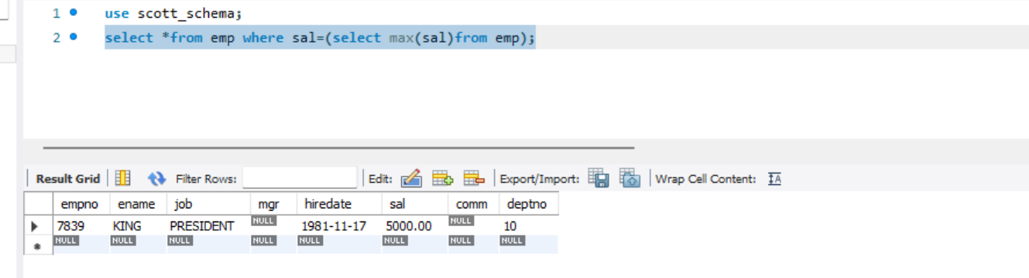

2.display the details of employee who is getting minimum salary?

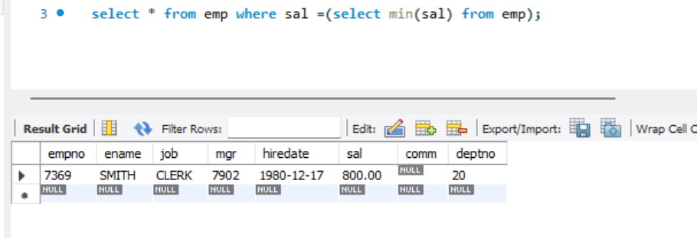

3. display the department information of smith?

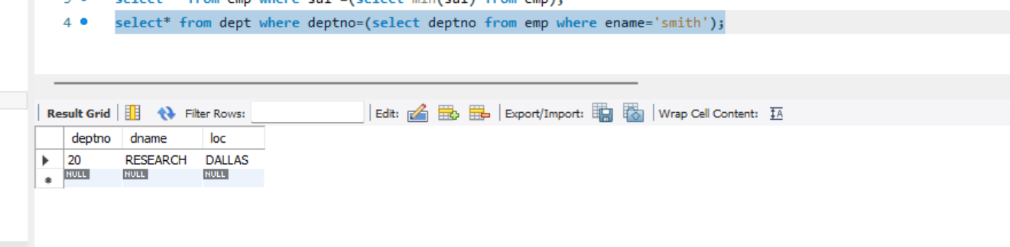

4. display the details of employee who is working in sales and research?

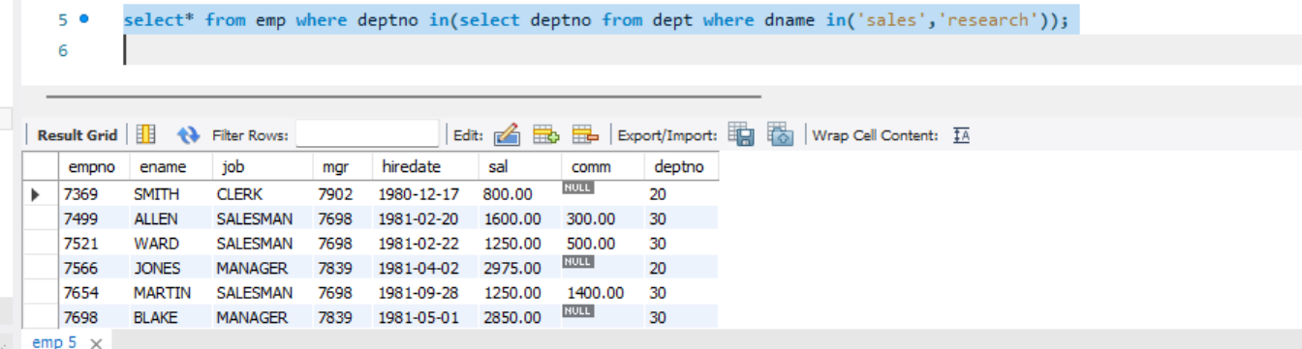

5. display the details of employee whose designation is same as ‘jones ?

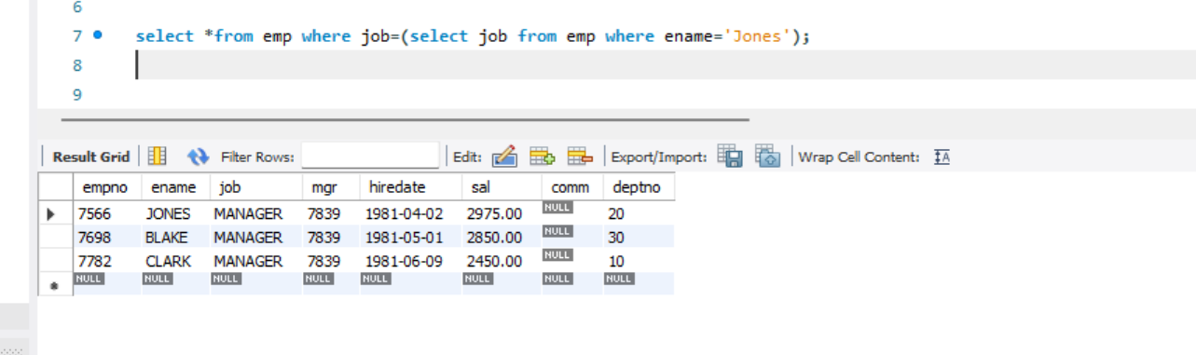

6. A query to fetch name and designation of emp whose salary is same as ‘martin’ salary ?

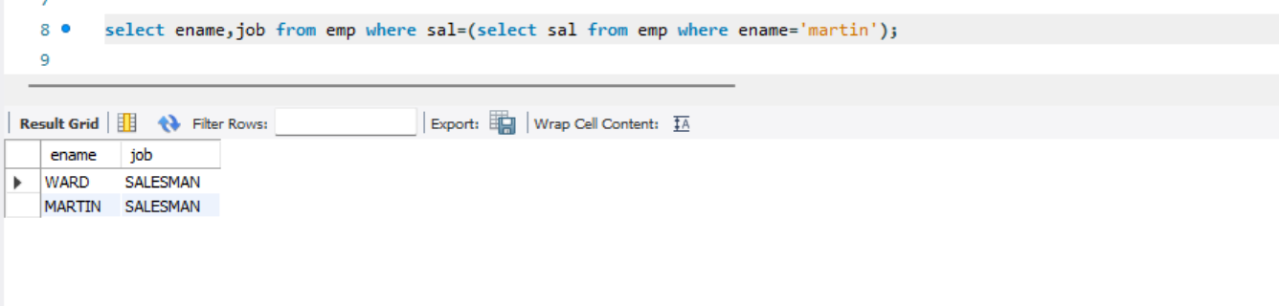

7.Display the department name of employee whose designation is end with ‘n’?

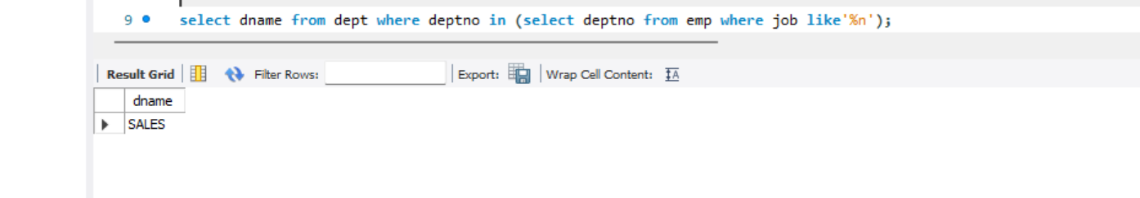

8.Display the employee details whose salary is greater than miller salary?

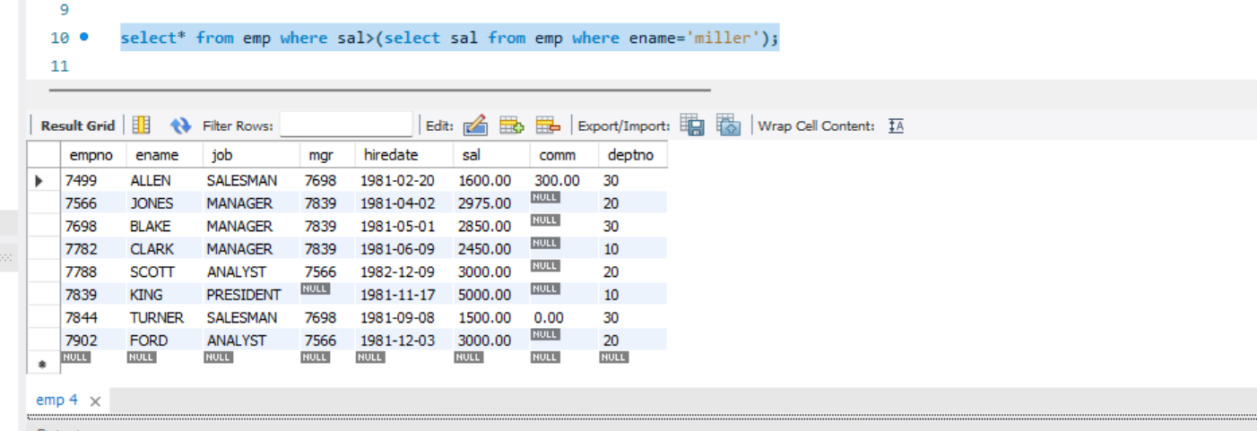

9.Display the details of employee smith manager?

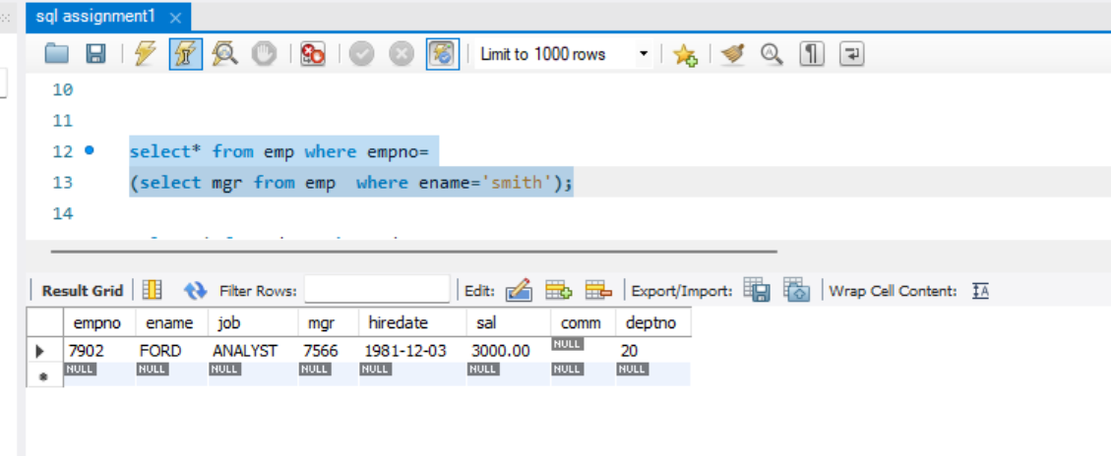

10. Display the department details those who do not have reporting manager?

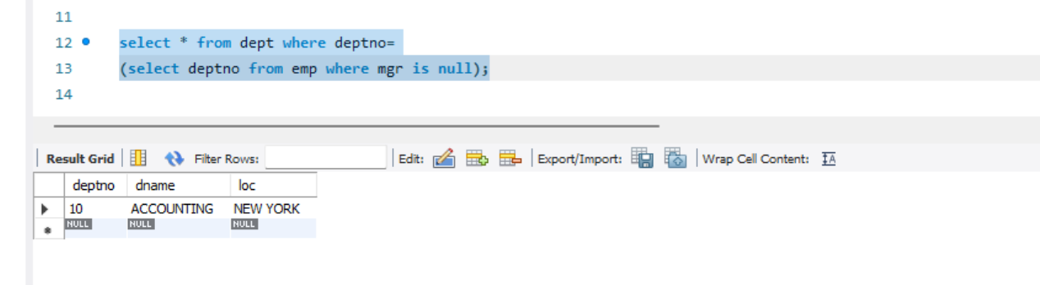

11. list all the employee details greater than average salary deptno =20?

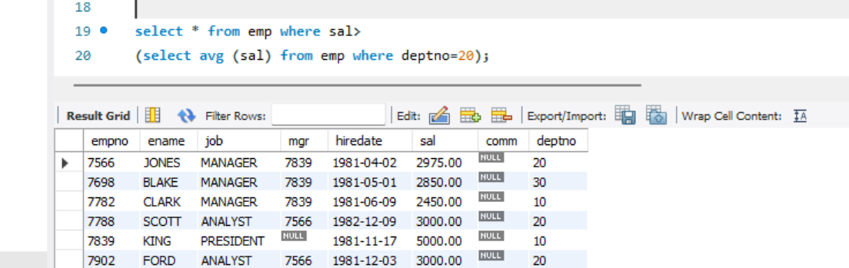

12. Display the department name of employee who are not getting commission?

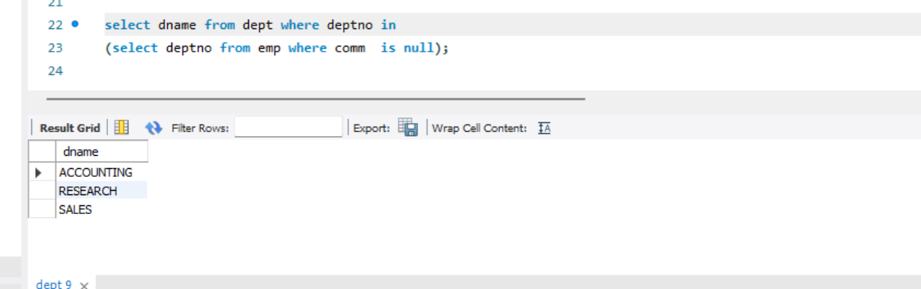

13. Select all the emp who are working in dallas?

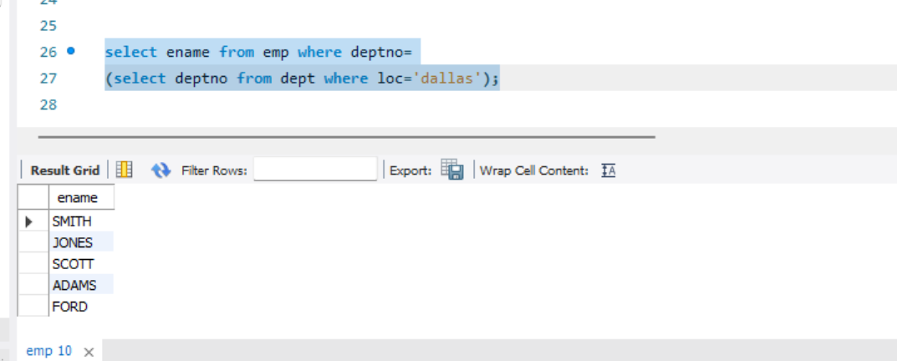

14. Display the details smith manager’s manager?

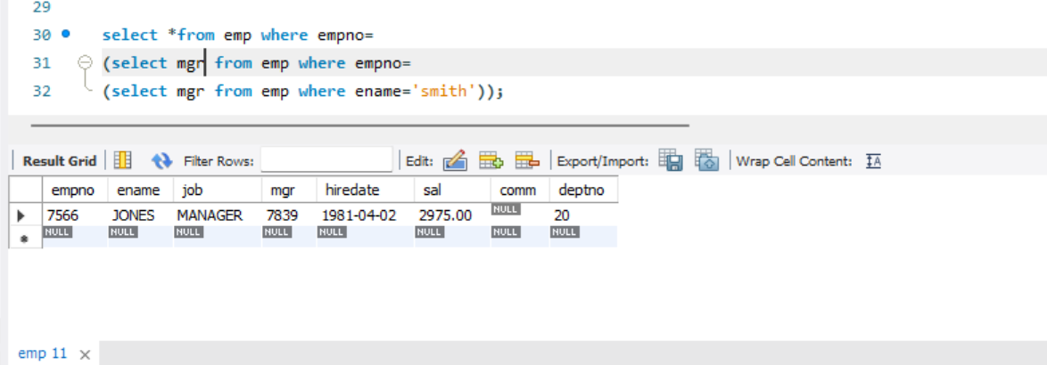

15. Display the department name of employee who is getting maximum commission?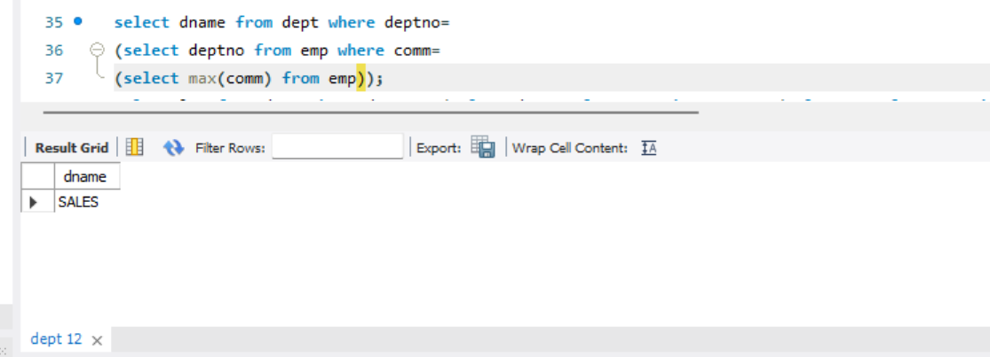

16. Display the location of smith manager’s manager?

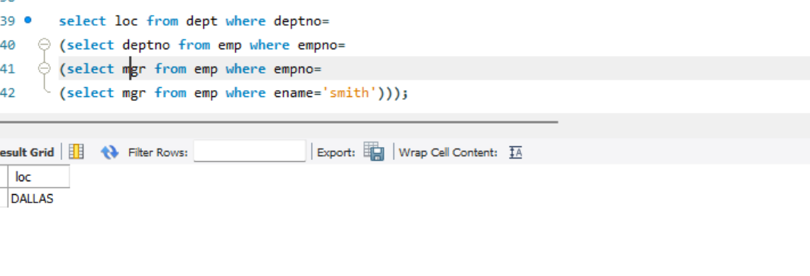

17. ) Display the name and designation of employee who is getting maximum salary in account department?

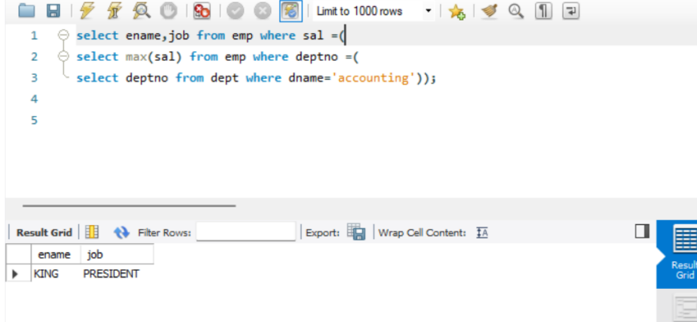

18. Display the no of employees has location is same as ‘adam’ manager loc?

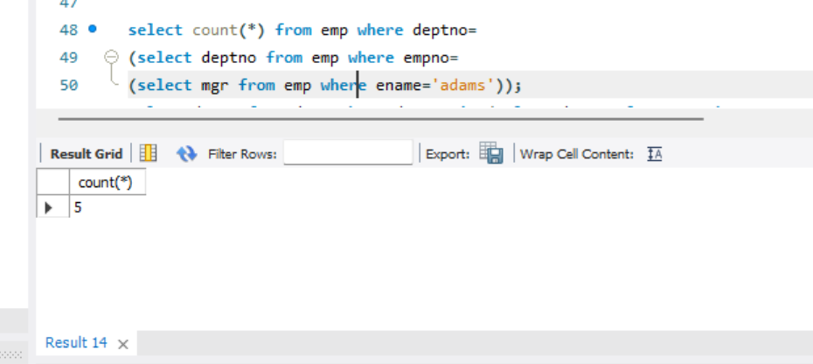

19. Display the dept name of emp whose name is does not start with ‘s’ and salary lies between 1500 to 3000?

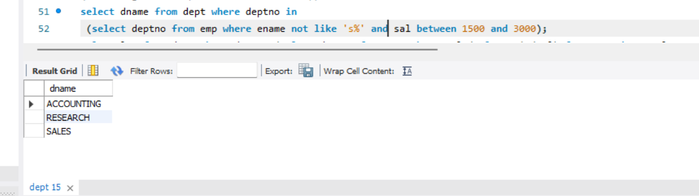

20 Display the location of employee whose is getting min salary but salary is greater than 2000?

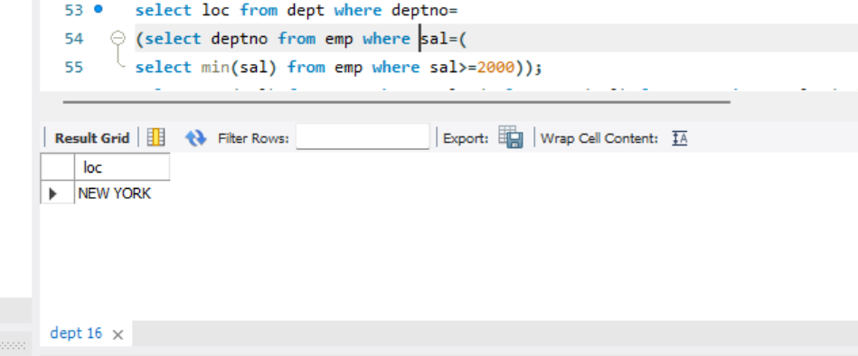

21. Display the third highest salary?

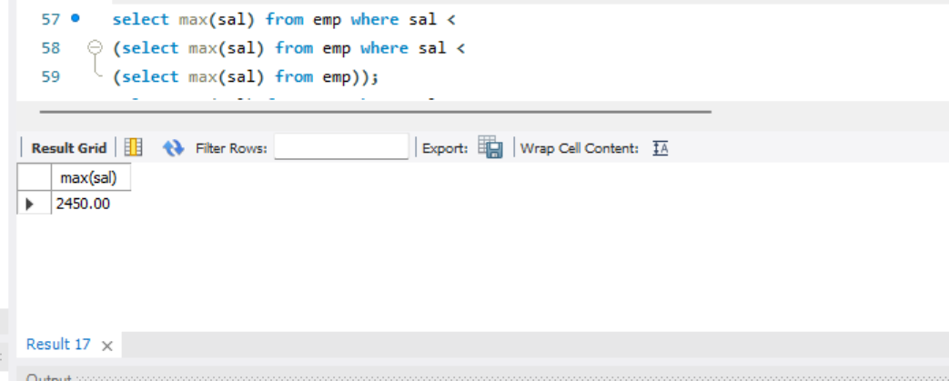

22. 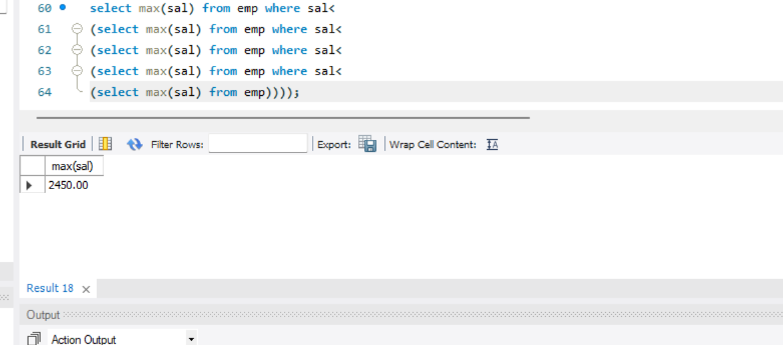

23. Display the loc and length of loc of all the salesman and analyst?

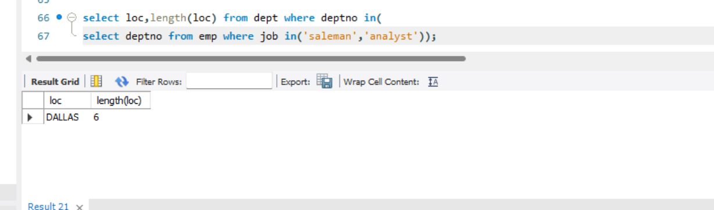

24. Display the first 3 characters of employee designation who are working in chicago?

